**SETUP GUIDE**

* Put the project files in /opt, so it should look like this when you use the command: **ls -l**

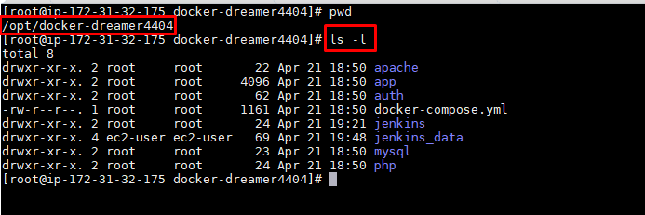

* Give permission to the Jenkins data folder and the app folder like this:
* **chown -R 1000:1000 jenkins_data**
* **chown -R 1000:1000 app**
* Bring all the services up wi the next command: **1. /usr/local/bin/docker-compose up -d**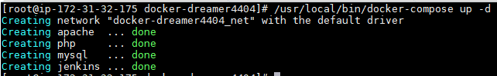
* **Go to the browser, and open Jenkins:** <http://18.189.2.229:8080>

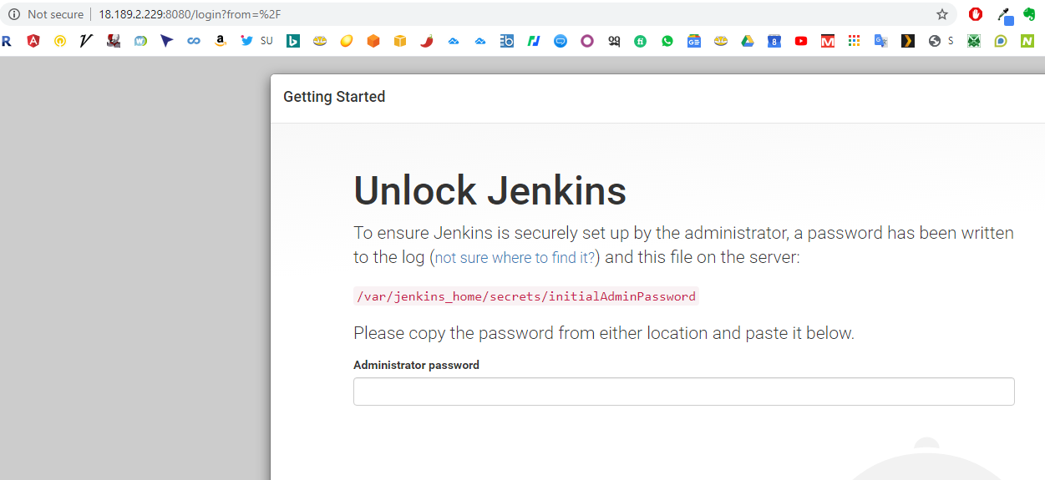

* **To get the administrator password, go to the terminal and run this command:**

1. **docker logs jenkins**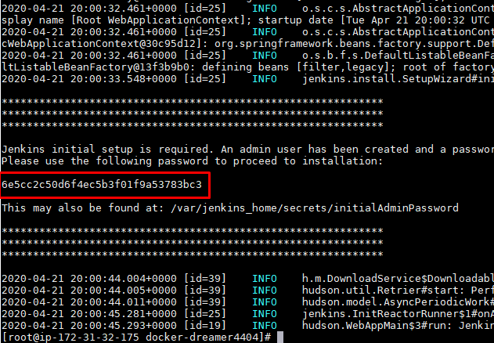

The red string above in the administrator password, copy that and paste in the browser.

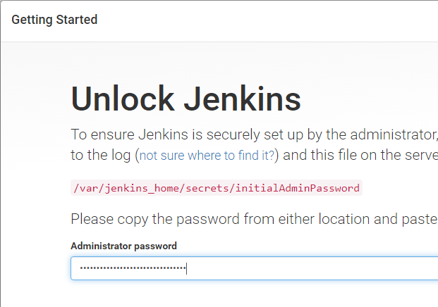

**And click “continue” button below.**

**Select “install suggested plugins”**

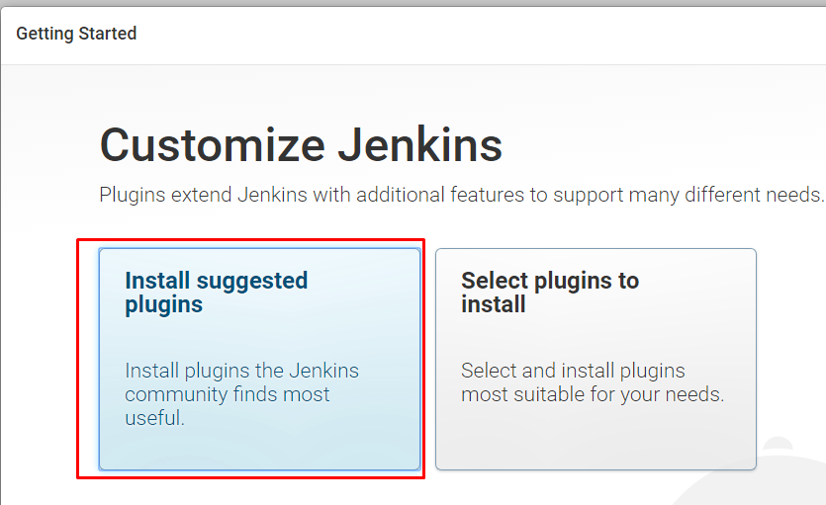

**Wait for the process to finish.**

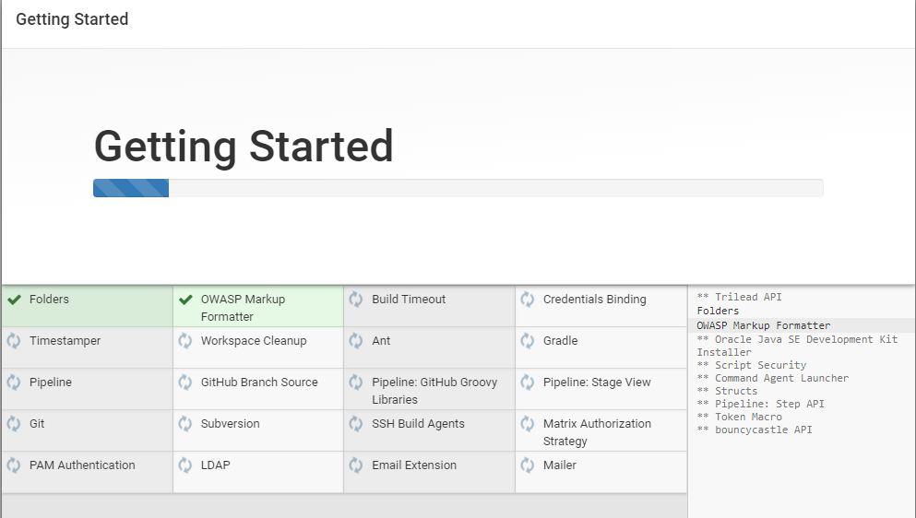

**Fill out the form with user information**

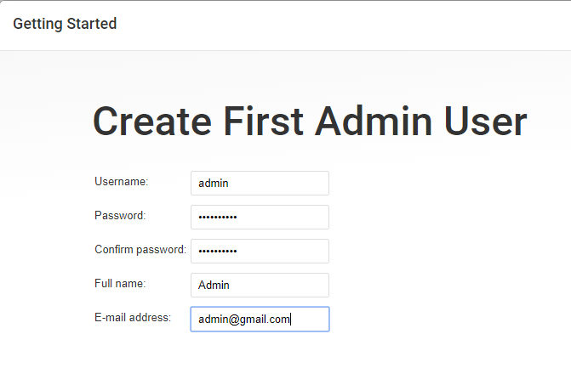

**Click on “Save and continue ” button below**

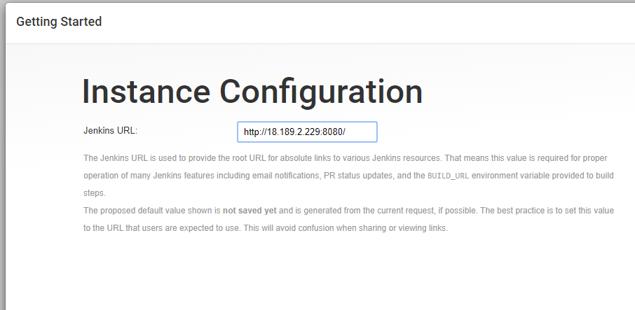

**Click on “Save and finish” button.**

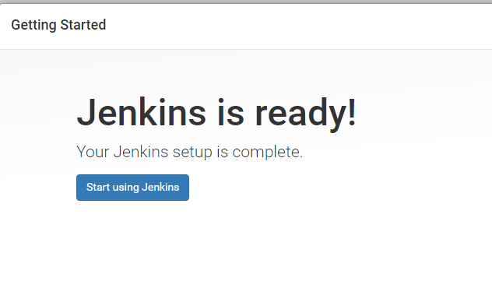

**Click on “Start using Jenkins”.**

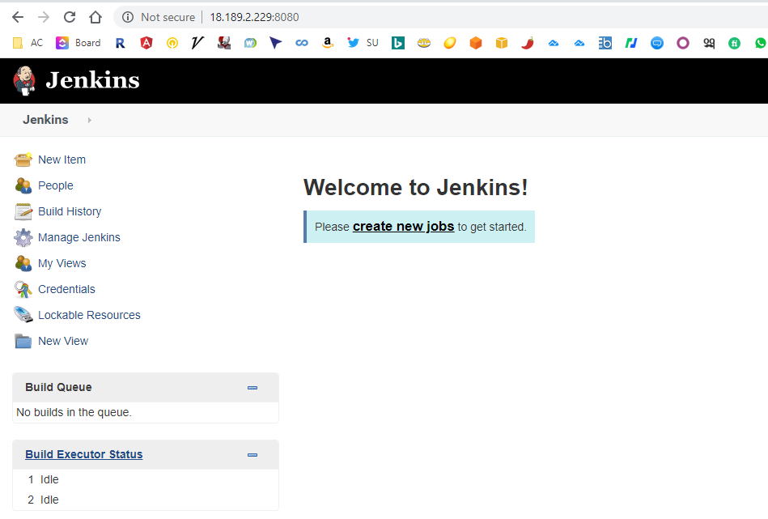

* **Select create “new job” and choose Freestyle Project**

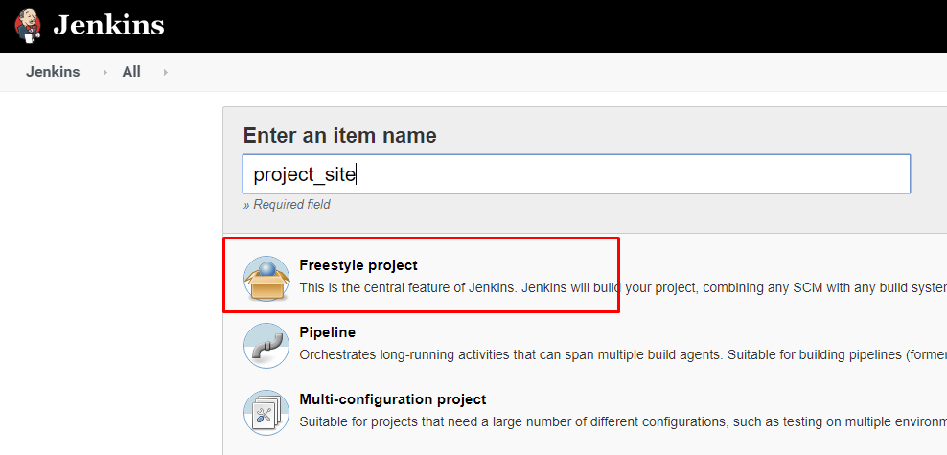

**In Source Code management select Repository URL:** https://github.com/heythatisz00/site_2

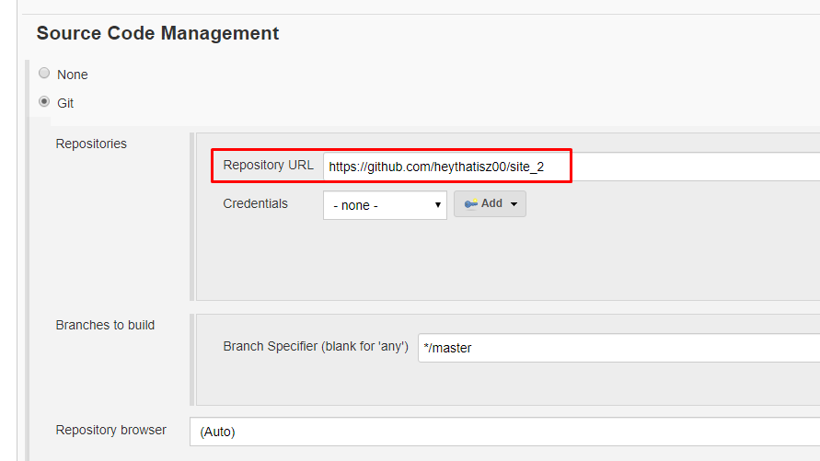

**Select “Github hook trigger for GITScm polling”**

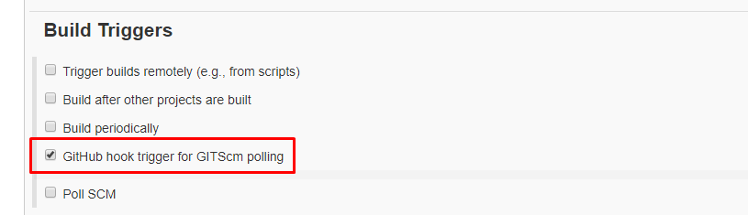

**In BUIL section select “Add build step” -> “Execute shell”**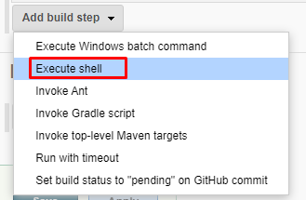

**In execute shell area add the following code:**

**DESTINATION_PATH=/app  
RSYNC_PARAMS='-rl --del --exclude=.git --exclude rsync.log --log-file=rsync.log '**

**rm -Rf /app/\***

**# deploy sources  
eval rsync $RSYNC_PARAMS ./ $DESTINATION_PATH**

**It should look like this:**

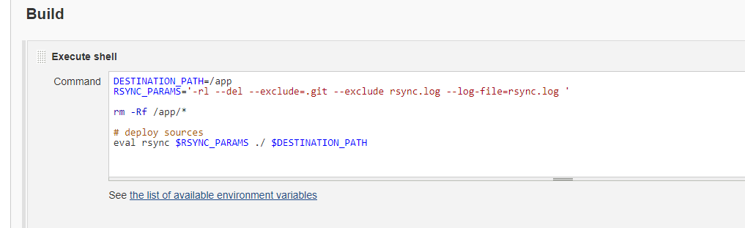

**Set-Up the proper webhook in the Github repository:**

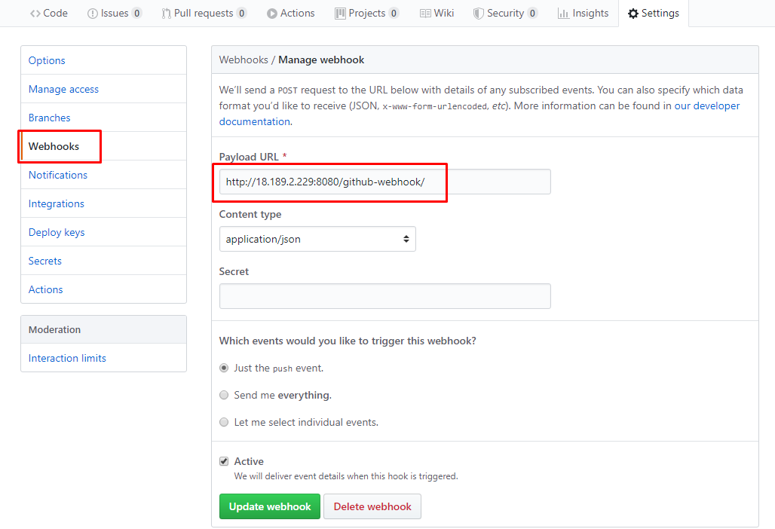

**By now, you should be able to push code changes to the repo and see Jenkins automatically trigger the job:**

**On the console output of the trigger job you should look for something like this:**

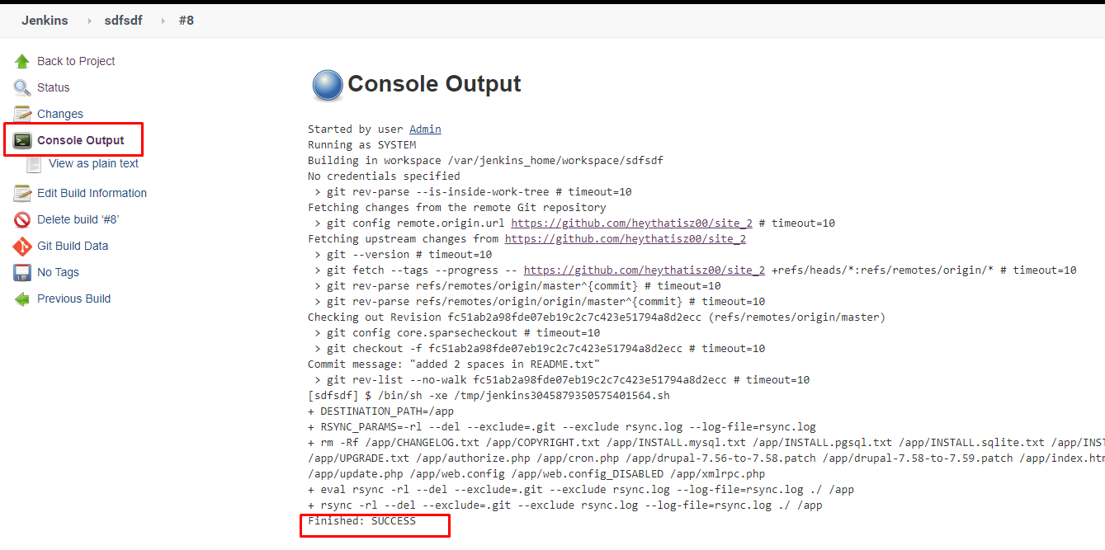

**In the server you should be able to look for the change in the app folder like this, and then use nano or another editor to check if the change is there, like I did before:**

